- Read again the first part of the source from lines 1 – 5.
List four things you learn from this part of the text about the day. [4 marks]

- Look in detail at this extract from lines 6 – 12 of the Source.
The man had been taken outside a small holdfast in the hills. Robb thought he was a wildling, his sword sworn to Mance Rayder, the King-beyond-the-Wall. It made Bran's skin prickle to think of it. He remembered the hearth tales Old Nan told them. The wildlings were cruel men, she said, slavers and slayers and thieves. They consorted with giants and ghouls, stole girl children in the dead of night, and drank blood from polished horns. And their women lay with the Others in the Long Night to sire terrible half-human children.
But the man they found bound hand and foot to the holdfast wall awaiting the king's justice was old and scrawny, not much taller than Robb. He had lost both ears and a finger to frostbite, and he dressed all in black, the same as a brother of the Night's Watch, except that his furs were ragged and greasy.

How does the writer use language here to present the Wildlings and the man waiting to be executed?

You could include the writer’s choice of:
- Words and phrases
- Language features and forms [8 marks]

- You now need to think about the whole of the Source.
This text is from the opening of a novel. How has the writer structured the text to interest you as a reader?
You could write about:
- What the writer focuses your attention on in the beginning
- How and why the writer changes the focus as the Source develops
- Any other structural features that interest you. [8 marks]

- Focus this part of your answer on the second part of the Source from line 13 to the end.

A student, having read this section of the text, said: “The writer brings the character of Bran’s father, Lord Stark, to life and tries to show the different sides of him.” To what extent do you agree?

In your response you could:
- Write about your own impressions Lord Stark and his portrayal
- Evaluate how the writer has created these impressions
- Support your opinions with reference to the text [20 marks]

Section B: Writing

You are advised to spend about 45 minutes on this section.
Write in full sentences.
You are reminded of the need to plan your answer.
You should leave enough time to check your work at the end.

- A magazine has asked for contributions for their creative writing section.

Either

Write a description suggested by this picture:

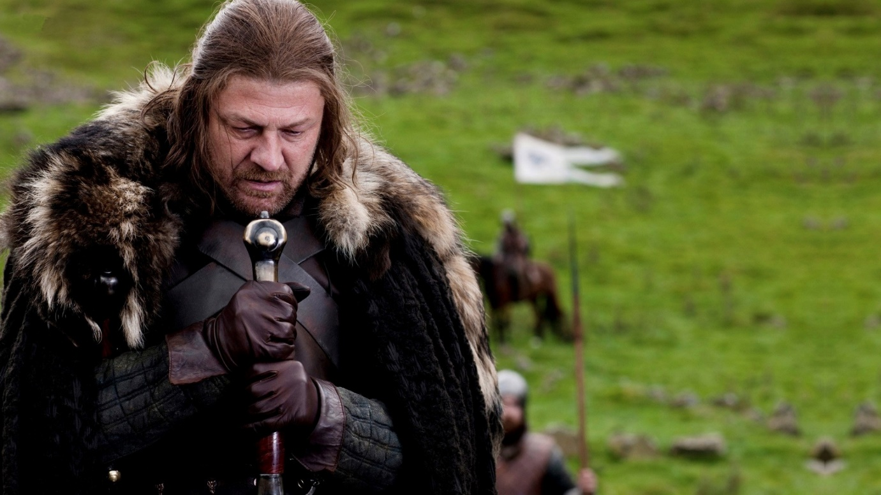

Or

Write a story about being in a difficult situation.

(24 marks for content and organisation
16 marks for technical accuracy)
[40 marks]

